Hi, I’m a document created in Word with an image & a caption.
I was Opened In Libre Office and an image with a new caption was added.

Figure 1 This image & Caption is added in MS office

This image and caption is been added in Libreoffice
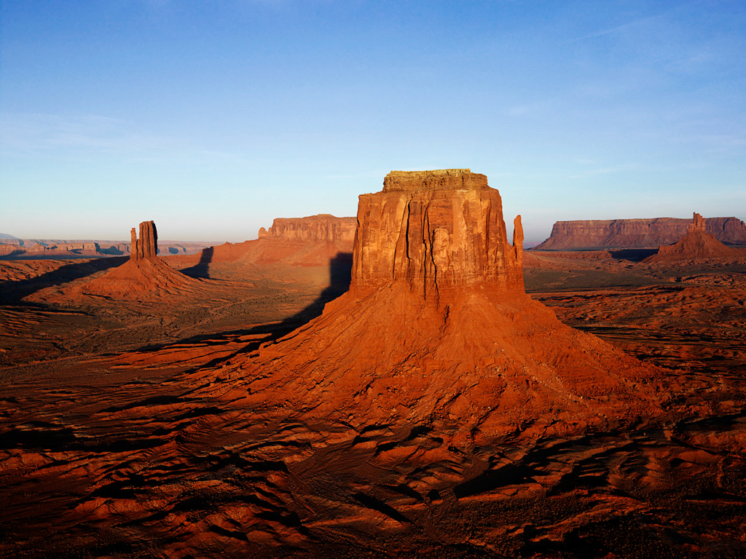
Illustration 1: Figure

